|  |  |  |
| --- | --- | --- |
|  | **SRI KRISHNA COLLEGE OF TECHNOLOGY**  **An Autonomous Institution | Accredited by NAAC with 'A' Grade**  **Affiliated to Anna University | Approved by AICTE**  **KOVAIPUDUR, COIMBATORE – 641042** |  |

**MENTALITY PLUS**

**A PROJECT REPORT**

***Submitted by***

**VIGNESH VASU 727822TUCS252**

***In partial fulfilment for the award of the degree***

***of***

**BACHELOR OF ENGINEERING**

**IN**

**COMPUTER SCIENCE AND ENGINEERING**

**FEBRUARY 2023**

**BONAFIDE CERTIFICATE**

Certified that this project report **“MENTALITY PLUS”** is the bonafide work of **VIGNESH VASU 727822TUCS252** who carried out the project work under my supervision.

|  |  |
| --- | --- |
| *SIGNATURE*  **Mr. V. VENKATESH**  **SUPERVISOR**  Assistant Professor,  Department of Computer Science and Engineering,  Sri Krishna College of Technology,  Coimbatore-641042 | *SIGNATURE*  **Dr. R. VIDHYA**  **HEAD OF THE DEPARTMENT**  Professor,  Department of Computer Science and Engineering,  Sri Krishna College of Technology,  Coimbatore-641042 |

Certified that the candidate was examined by me in the Project Work Viva Voce examination held on ______________ at Sri Krishna College of Technology, Coimbatore-641042.

|  |  |
| --- | --- |
| **INTERNAL EXAMINER** | **EXTERNAL EXAMINER** |

**ACKNOWLEDGMENT**

First and foremost, I thank the **Almighty** for being my light and for showering his gracious blessings throughout the course of this project.

I am grateful to my beloved Dean-Academics **Dr. P. Manju** and Dean-Administration **Dr. R. Ramesh Kumar for** their tireless and relentless support.

I extend my sincere thanks to our Head of the Department **Dr. R. Vidhya** for her encouragement and inspiration.

I am greatly indebted to my industry mentor **Ms. Freda** and project guide **Mr. V. Venkatesh,** Assistant Professor, Department of Computer Science and Engineering for their valuable guidance and suggestions in all aspects that aided me to ameliorate my skills.

I am thank full to all those who have directly and indirectly extended their help to me in completing this project.

**ABSTRACT**

Mental health refers to a person's emotional, psychological, and social well-being. It affects how we think, feel, and behave in our daily lives and influences how we handle stress, relate to others, and make choices. Good mental health enables us to cope with life's normal up sand downs, work productively, and make a meaningful contribution to our community. Taking care of our mental health is important for overall health and well-being, and seeking help when needed is a sign of strength and courage. Mental health problems can arise from a variety of causes, including biological, genetic, environmental, and life events such as trauma, abuse, and loss. Recognizing the signs of poor mental health, such as changes in mood, sleep patterns, and behavior, and seeking help from a mental health professional can lead to earlier diagnosis and treatment, which can improve outcomes and quality of life. There are a variety of treatments available for mental health problems, including therapy, medication, and lifestyle changes such as exercise, healthy eating, and stress management techniques. ‘Mentality Plus’ allows people to share their thoughts and feelings. People can Convey their story to others logged in to the platform. People can contact and rectify their personal and mental issues. This Website also has mood specific songs. Listening to music can calm our minds. The wholesome aim is to reduce mental illness and make people happy.

**LIST OF ABBREVATIONS**

|  |  |
| --- | --- |
| **ABBREVATION** | **EXPANSION** |
| HTML | HYPER TEXT MARKUP LANGUAGE |
| CSS | CASCADING STYLE SHEET |
| JS | JAVASCRIPT |
| OS | OPERATING SYSTEM |
| VS | VISUAL CLOUD STUDIO |
| RAM | RANDOM ACCESS MEMORY |
| IDE | INTEGRATED DEVELOPMENT ENVIRONMENT |

**LIST OF FIGURES**

|  |  |
| --- | --- |
| **FIGURE NO.** | **TITLE** |
| Fig 3.1 | Software Development Life Cycle |
| Fig 6.1 | Login Page |
| Fig 6.2 | Sign Up Page |
| Fig 6.3 | Home Page |
| Fig 6.4 | Nav Bar |
| Fig 6.5 | Side Nav |
| Fig 6.6 | Share Your Story Page |
| Fig 6.7 | Curated Song Playlist Page |
| Fig 6.8 | Feedback Page |

**TABLE OF CONTENTS**

|  |  |  |
| --- | --- | --- |
| **CHAPTER NO.** | **TITLE** | **PAGE NO.** |
|  | **ABSTRACT** | **i** |
|  | **LIST OF ABBREVATION** | **ii** |
|  | **LIST OF FIGURES** | **iii** |
| **1.** | **INTRODUCTION** |  |
|  | 1.1 OVERVIEW | 1 |
|  | 1.2 STATEMENT OF THE PROBLEM | 1 |
| **2.** | **OBJECTIVES OF THE WORK** |  |
|  | 2.1 SCOPE OF THE WORK | 2 |
|  | 2.2 SIGNIFICANCE OF THE WORK | 2 |
| **3.** | **METHODOLOGY** | 3 |
| **4.** | **REQUIREMENT SPECIFICATION** |  |
|  | 4.1 SYSTEM REQUIREMENTS | 5 |
|  | 4.2 FUNCTIONAL REQUIREMENTS | 5 |
|  | 4.3 BUISNESS MODEL | 5 |

|  |  |  |
| --- | --- | --- |
| **5.** | **PROJECT DESIGN** |  |
|  | 5.1. LANGUAGES | 7 |
| **6.** | **PROJECT IMPLEMENTATION** |  |
|  | 6.1 LOGIN PAGE | 8 |
|  | 6.2 SIGN UP PAGE |  |
|  | 6.3 HOME PAGE |  |
|  | 6.4 SHARE YOUR STORY PAGE |  |
|  | 6.5 CURATED SONGS PLAYLIST PAGE |  |
|  | 6.6 FEEDBACK PAGE |  |
| **7.** | **CONCLUSION AND FUTURE SCOPE** |  |
|  | 7.1 CONCLUSION  7.2 FUTURE SCOPE |  |
| **8.** | **REFERENCES** |  |

**CHAPTER-1**

**INTRODUCTION**

**1.1 OVERVIEW**

Mental health is a critical aspect of overall well-being that affects an individual's thoughts, behaviours, emotions, and moods. One of the major challenges in addressing mental health is the stigma surrounding it. Many people are reluctant to seek help or admit to having mental health problems due to the shame and discrimination often associated with mental illness. This stigma leads to underdiagnosis and undertreatment, resulting in many people struggling with mental health issues in silence. Another issue is the lack of access to mental health services and resources, particularly in underserved communities. Many people do not have access to mental health care, either because of financial constraints or a lack of availability of mental health professionals. This exacerbates the problem, as people are unable to receive the care and support, they need to manage their mental health.

Top of Form

**1.2 STATEMENT OF PROBLEM**

Mental health remains a significant problem, with many challenges that must be addressed, including stigma, lack of access to resources and services, and limited understanding of mental health conditions. Addressing these issues is critical for improving the mental health and well-being of individuals and communities around the world.

**CHAPTER-2**

**OBJECTIVES OF THE WORK**

**2.1 SCOPE OF THE WORK**

The main objective of the project is to provide individuals with convenient and accessible tools to support their mental well-being. Users can gain insights into their mental health and identify patterns and triggers. It offers virtual therapy sessions or connect users with licensed therapists to receive one-on-one support. It offers forums, chat rooms, and other types of social support to connect users with others who are experiencing similar mental health challenges.

**2.2 SIGNIFICANCE OF THE WORK**

* Convenience: It can be used anywhere, at any time, making it easier for people to manage their mental health.
* Affordability: It free of cost, providing access to mental health support to those who may not have the resources to see a therapist in person.
* Anonymity: For people who are not comfortable talking about their mental health, it offers a way to manage symptoms and receive support anonymously.
* Customization: It allow users to personalize their experience based on their specific needs and preferences.
* Accessibility: It can be used by people with disabilities or mobility issues who may not be able to attend in-person therapy sessions.

**CHAPTER-3**

**METHODOLOGY**

Fig 3.1 Software Development Life Cycle

* User Research: Conducting user research to understand the needs and preferences of the target audience is crucial in developing a mental health website that is effective and usable.
* Ideation and Prototyping: After conducting user research, the next step is to ideate and prototype the website. This involves creating sketches, wireframes, and prototypes of the websites to test and refine its design and functionality.
* Development and Testing: The development and testing phase involves coding and testing the mental health website to ensure that it works as intended and meets the needs of users.
* Launch and Deployment: Once the website has been developed and tested, it can be launched and deployed for use.
* Ongoing Maintenance and Support: Mental health website require ongoing maintenance and support to ensure that they remain effective and relevant to users over time.

**CHAPTER-4**

**REQUIREMENTS SPECIFICATION**

**4.1 SYSTEM REQUIRMENTS**

Minimum Requirements:

OS: Windows/Linux

Architecture: x86 or x64 (32-bit or 64-bit processor)

Processor: Intel Pentium 4 or AMD Athlon XP

Ram:4 GB

**4.2 FUNCTIONAL REQUIREMENTS**

Register account: The user should be able to create an account using his personal information (Full Name, Email Address).

Email/Password Authentication: The user Should be able to log in to the website using his credentials (Username and Password).

**4.3 BUSINESS MODEL**

* Users can contact trained therapist whenever they need.
* Users can share their story.
* Users data will be safe and kept anonymous.
* User can listen to songs. The songs are mood specific.
* Users can give feedback
* They can tell if the website helped them
* And give feedback what we can improve.

In today's society, there are also several emerging mental health issues such as technology addiction, social media anxiety, and burnout. The COVID-19 pandemic has also had a significant impact on mental health, leading to increased levels of stress, anxiety, and depression in many people around the world. It's important to remember that mental health is just as important as physical health and seeking help is a sign of strength. After witnessing this I got an idea for the website, to provide support for people in need.

**CHAPTER-5**

**PROJECT DESIGN**

**5.1 LANGUAGES**

* **Java Script:** JavaScript is an extensive and popular scripting language that is used to create interactive and dynamic web content like applications and browsers. It is the client-side language that is the most famous and the most-used in the world.
* **HTML:** HTML is the code that is used to structure a web page and its content. For example, content could be structured within a set of paragraphs, a list of bulleted points, or using images and data tables.
* **CSS:** CSS is used to style and layout web pages - for example, to alter the font, colour, size, and spacing of content, split it into multiple columns, or add animations and other decorative features.
* **Microsoft Visual Studio:** Visual Studio Visual Studio was the main integrated development environment (IDE) for developing application. Visual Studio Code, also commonly referred to as VS Code, is a source-code editor made by Microsoft with the Electron Framework, for Windows, Linux and macOS. Features include support for debugging, syntax highlighting, intelligent code completion, snippets, code refactoring, and embedded Git.

**CHAPTER-6**

**PROJECT IMPLEMENTATION**

**6.1 LOGIN PAGE**

Login page consist of title name and a short note on the website, the user has to enter the required credentials such as username and password to log into the website. If the user doesn’t have a account he can create a new account.

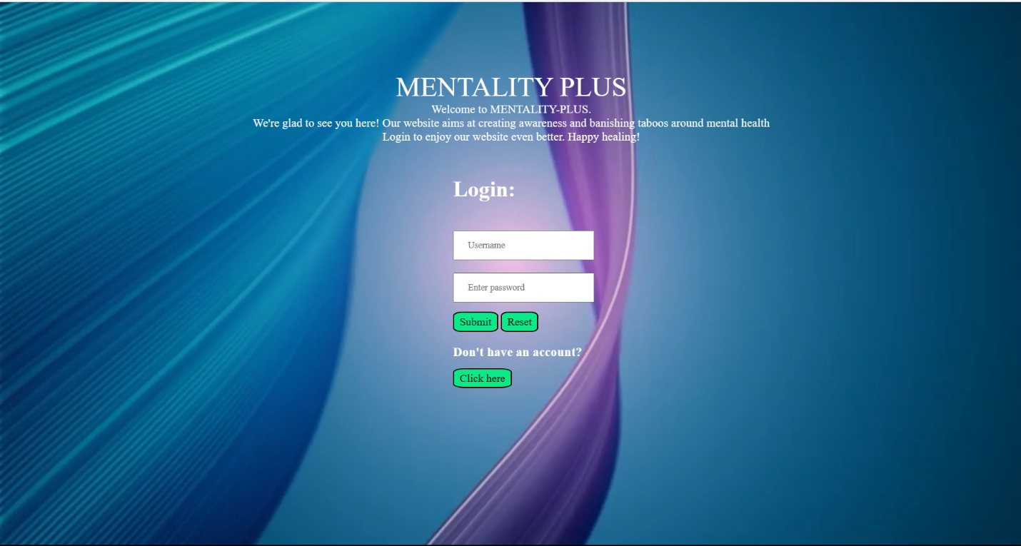

**Fig 6.1 Login page**

**Login.html**

<!DOCTYPE html>

<html>

    <head>

        <link rel="stylesheet" type="text/css" href="login.css">

        <title>

            Login/Sign-up

        </title>

        <script>

        </script>

        <video id="myVideo1" autoplay loop muted>

            <source src="reg_video.mp4" type="video/mp4" />

        </video>

    </head>

    <body>

        <div id="imgp">

        <p id="pagetitle">MENTALITY PLUS</p>

        <p id="intro1">Welcome to MENTALITY-PLUS.

        </br>

We're glad to see you here! Our website aims at creating awareness and banishing taboos around mental  health  </br> Login to enjoy our website even better. Happy healing! </p>

        </div>

        <div id="login">

        <form action="/login" method="post">

        </br></br>

        <h1 id="form__title">Login:</h1></br></br>

        <input type="text" id="log" autofocus name="name" placeholder="Username"></input></br></br>

        <input type="password" class="log" name="password" id="pass" placeholder="Enter password"></input></br></br>

        <button id="reset" type="reset" onclick="window.location.href='main.html'" >Submit</button>

        <button id="reset" type="reset" onclick="window.location.href='login.html'">Reset</button>

        </form>

        <form action="/register" method="post">

            </br><h3 class="link">Don't have an account?</h3>

            <br>

             <a href="register.html" class="link1">Click here</a>

        </form>

    </div>

</body>

</html>

**Login.css**

*{

    margin: 0;

    padding: 0;

    font-family: 'Times New Roman', Times, serif;

    }

#myVideo1{

        position: fixed;

        right: 0;

        bottom: 0;

        min-width: 100%;

        min-height: 100%;

        z-index:-2;

}

#pagetitle{

    text-align:center;

    left:150px;

    margin-top: 100px;

    color:white;

    font-size: 40px;

}

#intro1{

    text-align:center;

    left:400px;

    top : 55px;

    color:white;

    font-size: 17px;

}

#login{

    position: relative;

    top:10px;

    left: 460px;

    height: 380px;

    width: 335px;

}

#para

{

    text-align: top;

    position: relative;

    font-size:small;

}

#login{

    border: "2px";

    border-color: white;

    margin-left: 200px;

}

#form__title{

    text-align:left;

    left: 40px;

    top : 20px;

    color:white;

}

#log,#pass,#email{

    position: relative;

    top : 5px;

    padding: 12px 20px;

}

#buttons

{

    position: relative;

    top:100px;

    height:16px;

    left: 20;

}

#submit,#reset{

    padding: 4px 8px;

    border-radius: 20%;

    font-size: 16px;

    background-color: #0de989;

    color:rgb(17, 15, 15);

  }

.logo{

    position:fixed;

    display: inline;

    top:58px;

    left:29px;

    width:6%

}

.link{

  color:white;

}

.link1{

    color:black;

    text-decoration: none;

    padding: 4px 8px;

    border-radius: 20%;

    border:2px solid black;

    font-size: 16px;

    background-color: #0de989;}

**6.1.2 SIGN UP PAGE**

Sign up page consist of title name and a short note on the website. When the user doesn’t have an account, he will be redirected to this page The user has to enter the credentials such as username, password and email id. After clicking the submit button, account will be created and redirected to the login page. Then the user can log in to website.

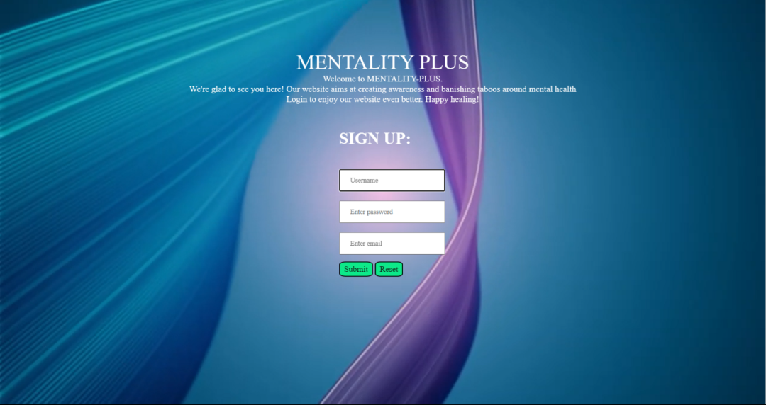

**Fig 6.2 Sign up page**

**Register.html**

<!DOCTYPE html>

<html>

    <head>

        <link rel="stylesheet" type="text/css" href="register.css">

        <title>

            Registration

        </title>

        <video id="myVideo1" autoplay loop muted>

            <source src="reg_video.mp4" type="video/mp4" />

        </video>

          </head>

    <body>

                <div>

        <p id="pagetitle">MENTALITY PLUS</p>

        <p id="intro1">

            Welcome to MENTALITY-PLUS.

        </br>

        We're glad to see you here! Our website aims at creating awareness and banishing taboos around mental health

     </br>

     Login to enjoy our website even better. Happy healing!

     </p>

        </div>

           <div id="login">

               <form action="/reg_success" method="post">

        </br>

</br>

        <h1 id="form__title">SIGN UP:</h1>

</br>

</br>

        <input type="text" id="log" autofocus name="name" required placeholder="Username"></input>

</br>

</br>

        <input type="password" class="log" name="password" required id="pass" placeholder="Enter password"></input>

</br>

</br>

        <input type="email" id="email" required name="email" placeholder="Enter email"></input>

</br>

</br>

        <button id="reset" type="reset" onclick="window.location.href='login.html'" >Submit</button>

        <button id="reset" type="reset" onclick="window.location.href='main.html'">Reset</button>

        </form>

    </div>

</body>

</html>

**Register.css**

*{

    margin: 0;

    padding: 0;

    font-family: 'Times New Roman', Times, serif;

    }

#myVideo1{

        position: fixed;

        right: 0;

        bottom: 0;

        min-width: 100%;

        min-height: 100%;

        z-index:-2;

}

#pagetitle{

    text-align:center;

    left:150px;

    margin-top: 100px;

    color:white;

    font-size: 40px;

}

#intro1{

    text-align:center;

    left:400px;

    top : 55px;

    color:white;

    font-size: 17px;

}

#login{

    position: relative;

    top:10px;

    left: 460px;

    height: 380px;

    width: 335px;

}

#para

{

    text-align: top;

    position: relative;

    font-size:small;

}

#login{

    border: "2px";

    border-color: white;

    margin-left: 200px;

}

#form__title{

    text-align:left;

    left: 40px;

    top : 20px;

    color:white;

}

#log,#pass,#email{

    position: relative;

    top : 5px;

    padding: 12px 20px;

}

#buttons{

    position: relative;

    top:100px;

    height:16px;

    left: 20;

}

#submit,#reset{

    padding: 4px 8px;

    border-radius: 20%;

    font-size: 16px;

    background-color: #0de989;

    color:rgb(17, 15, 15);

}

.logo{

    position:fixed;

    display: inline;

    top:58px;

    left:29px;

    width:6%

}

.link{

    color:white;}

.link1{

    color:black;

    text-decoration: none;

    padding: 4px 8px;

    border-radius: 20%;

    font-size: 16px;

    background-color: #0de989;

}

**6.3 HOME PAGE**

Home page consist a brief note about the website. It has top nav bar consisting of ‘Home’, ‘Login’,

‘About the website’ and ‘Contact us’. It has a image carousel of mental illness, stress and peer pressure. Below that there is a short note on mental health. Below that there is a series of image in marquee. Below that in the footer there is contact details so that the user can contact us if they want to rectify there mental issues. It also have side nav which consist of ‘Share your story’, ‘Curated playlist ’, ‘Feedback’.

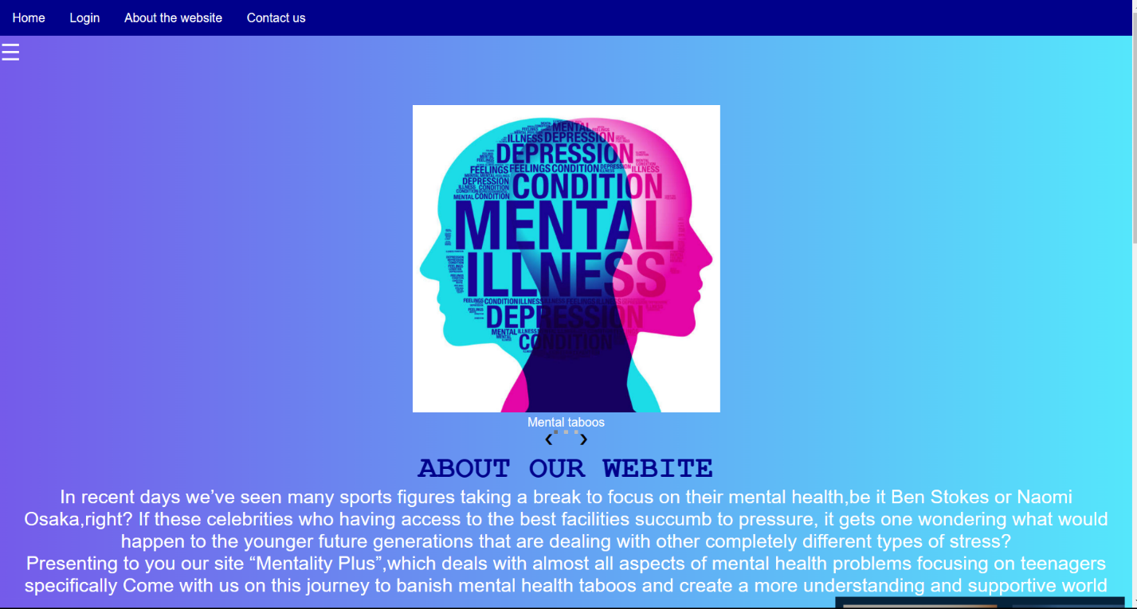

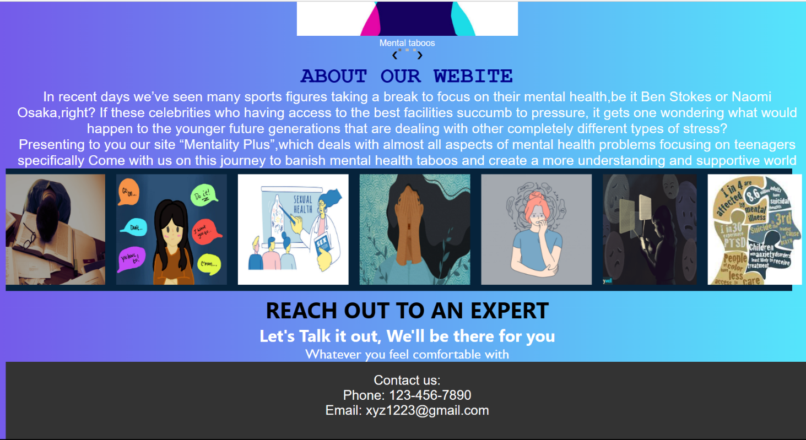

**Fig 6.3 Home page**

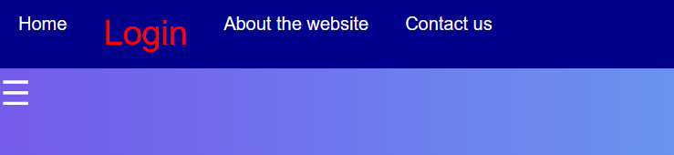

**Fig 6.4 Nav bar**

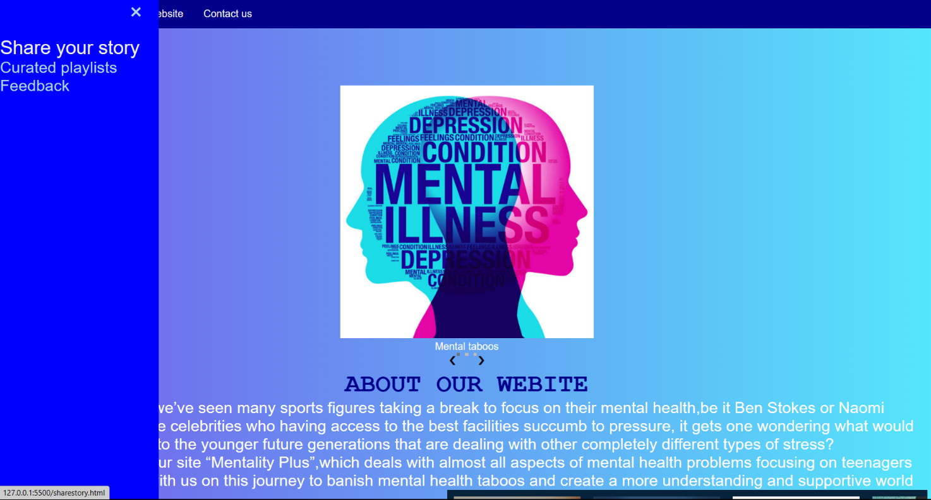

**Fig 6.5 Side nav**

**Main.html**

<!DOCTYPE html>

<html>

<head>

  <link rel="stylesheet" href="main.css">

</head>

<body>

  <div id="mySidenav" class="sidenav">

    <a href="javascript:void(0)" class="closebtn" onclick="closeNav()">&times;</a>

    <a href="sharestory.html" target="blank_">Share your story</a>

    <a href="spotify.html" target="blank_">Curated playlists</a>

    <a href="feedback_form.html" target="blank_">Feedback</a>

  </div>

  <div class="container">

    <ul>

      <li><a href="main.html">Home</a></li>

      <li><a href="login.html">Login </a></li>

      <li><a href="#aboutus">About the website</a></li>

      <li><a href="#contact">Contact us</a></li>

     </ul>

  </div>

  <span style="font-size:30px;cursor:pointer" onclick="openNav()">&#9776; </span>

  <div class="slideshow-container">

    <div class="mySlides fade">

      <img src="pic3.jpg" style="width:40%">

      <div class="text">Mental taboos</div>

    </div>

    <div class="mySlides fade">

      <img src="1.jpg" style="width:40%">

      <div class="text">Stress</div>

    </div>

    <div class="mySlides fade">

      <img src="2.jpg" style="width:40%">

      <div class="text">Peer pressure</div>

    </div>

    <a class="prev" onclick="plusSlides(-1)">&#10094;</a>

    <a class="next" onclick="plusSlides(1)">&#10095;</a>

  </div>

  <br>

  <div style="text-align:center">

    <span class="dot" onclick="currentSlide(1)"></span>

    <span class="dot" onclick="currentSlide(2)"></span>

    <span class="dot" onclick="currentSlide(3)"></span>

  </div>

  </div>

  <script>

    function openNav() {

      document.getElementById("mySidenav").style.width = "250px";

    }

    function closeNav() {

      document.getElementById("mySidenav").style.width = "0";

    }

    //for image slider using javascript

    var slideIndex = 1;

    showSlides(slideIndex);

    function plusSlides(n) {

      showSlides(slideIndex += n);

    }

    function currentSlide(n) {

      showSlides(slideIndex = n);

    }

    function showSlides(n) {

      var i;

      var slides = document.getElementsByClassName("mySlides");

      var dots = document.getElementsByClassName("dot");

      if (n > slides.length) { slideIndex = 1 }

      if (n < 1) { slideIndex = slides.length }

      for (i = 0; i < slides.length; i++) {

        slides[i].style.display = "none";

      }

      for (i = 0; i < dots.length; i++) {

        dots[i].className = dots[i].className.replace(" active", "");

      }

      slides[slideIndex - 1].style.display = "block";

      dots[slideIndex - 1].className += " active";

    }

  </script>

  <br>

  <center>

    <h1>ABOUT OUR WEBITE</h1>

  </center>

  <!-- ABOUT OUR WEBSITE HOME PAGE -->

  <div class="aboutus" id="aboutus">

    <center>

    <p>In recent days we’ve seen many sports figures taking a

      break to focus on their mental health,be it Ben Stokes

      or Naomi Osaka,right? If these celebrities who having

      access to the best facilities succumb to pressure, it gets one wondering what would happen to

      the younger future generations that are dealing with

      other completely different types of stress?</p>

      <p>Presenting

      to you our site “Mentality Plus”,which deals with almost all

      aspects of mental health problems focusing on

      teenagers specifically

      Come with us on this journey to banish mental health

      taboos and create a more understanding and

      supportive world </p></center>

      <marquee scrollamount="6">

    <div class="flex-containerimg">

      <div><img src="3.png" style="width:200px;height:200px;align-self: center;">

      </div>

      <div><img src="https://pldlamplighter.org/wp-content/uploads/2019/05/peerpressure-900x675.jpg"

          style="width:200px;height:200px"></div>

      <div><img

          src="https://media.istockphoto.com/vectors/school-sexuality-education-program-schools-lesson-on-safe-sex-teens-vector-id1268743281?k=20&m=1268743281&s=612x612&w=0&h=wU78MdUEVT8A_FOivzgwvgeE1fsDFfT11nBOmgiSU7k="

          style="width:200px;height:200px"></div>

          <div><img src="4.jpg" style="width:200px;height:200px;align-self: center;">

          </div>

          <div><img src="5.jpg" style="width:200px;height:200px;align-self: center;">

          </div>

          <div><img src="6.png" style="width:170px;height:200px;align-self: center;">

          </div>

          <div><img src="7.jfif" style="width:170px;height:200px;align-self: center;">

          </div>

    </div></marquee><br/>

    <h1 id="h1">REACH OUT TO AN EXPERT

    </h1>

    <h3>Let's Talk it out, We'll be there for you

    </h3>

    <center>

      <p id="p1">Whatever you feel comfortable with</p>

    </center>

    <footer>

      <div class="container">

        <p>Contact us:</p>

        <p>Phone: 123-456-7890</p>

        <p>Email: xyz1223@gmail.com</p>

      </div>

    </footer>

         </div>

    </body>

</html>

**Main.css**

*

{

  color:white;

  margin:0;

  padding:0;

}

body

{

  background: linear-gradient(90deg,#755bea,#55e7fc);

}

    /* ABOUT US IMAGES */

    .flex-containerimg {

      display: flex;

      flex-direction: row;

      background-color: rgb(6, 35, 59);

    }

    .flex-containerimg>div {

      width: 200px;

      margin: 10px;

      text-align: center;

      line-height: 22px;

      font-size: 30px;

    }

    h3 {

      font-family: 'Segoe UI', Tahoma, Geneva, Verdana, sans-serif;

      color: white;

      font-size: 30px;

    }

    h1#h1 {

      font-family: 'Segoe UI', Tahoma, Geneva, Verdana, sans-serif;

      color: black;

      font-size: 40px;}

        #p1 {

      font-family: 'Gill Sans', 'Gill Sans MT', Calibri, 'Trebuchet MS', sans-serif;

      color:white;

      font-size: 25px;

    }

    .flex-container {

      display: flex;

      justify-content: center;

       height: 188px;

    }

    .flex-container>div {

      /* background-color: black; */

      /* border: 2px solid black; */

      width: 300px;

      margin: 10px;

      text-align: center;

      line-height: 75px;

      font-size: 30px;

      background-color: lightskyblue;

    }

        body {

      font-family: "lato", sans-serif;

      height: 2000px;

    }

    .sidenav {

      height: 100%;

      width: 0;

      position: fixed;

      z-index: 1;

      top: 0;

      left: 0;

      background-color: blue;

      overflow-x: hidden;

      transition: 1s;

      padding-top: 60px;

    }

    .sidenav a {

      float:left

      padding: 8px 8px 8px 32px;

      text-decoration: none;

      font-size: 25px;

      color: lightblue;

      display: block;

      transition: 0.3s;

    }

    .sidenav a:hover {

      color: #f1f1f1;

    }

    .sidenav .closebtn {

      position: absolute;

      top: 0;

      right: 25px;

      font-size: 36px;

      margin-left: 50px;

    }

    .container {

          top: -1045px;

    }

    /* HORIZONTAL NAVBAR */

    ul {

      list-style-type: none;

      margin: 0;

      top: 10px;

      padding: 0;

      overflow: hidden;

      background-color: darkblue;

    }

    li {

      float: left;

    }

    li a {

      display: block;

      color: white;

      text-align: center;

      padding: 14px 16px;

      text-decoration: none;

    }

    a:hover {

      font-size: 30px;

      color: red;

    }

    /* Slideshow container */

    .slideshow-container {

      max-width: 1000px;

      position: relative;

      top: 51px;

      margin: auto;

      text-align: center;

    }

    /* Next & previous buttons */

    .prev,

    .next {

      cursor: pointer;

      position:relative;

      top: 50%;

      width:1px;

      padding: 16px;

      margin-top: -25px;

      color: rgb(5, 1, 1);

      font-weight: bold;

      font-size: 18px;

      transition: 0.6s ease;

      border-radius: 0 3px 3px 0;

      user-select: none;

    }

    /* Position the "next button" to the right */

    .next {

      right:0;

      border-radius: 3px 0 0 1px;

    }

    /* The dots/bullets/indicators */

    .dot {

      cursor: pointer;

      height: 5px;

      width: 5px;

      margin: 0 2px;

      background-color: #bbb;

      border-radius:10%;

      display: inline-block;

      transition: background-color 0.6s ease;

    }

    .active,

    .dot:hover {

      background-color: #717171;

    }

    /* Fading animation */

    .fade {

      -webkit-animation-name: fade;

      -webkit-animation-duration: 1.5s;

      animation-name: fade;

      animation-duration: 1.5s;

    }

    @-webkit-keyframes fade {

      from {

        opacity: .4

      }

      to {

        opacity: 1

      }

    }

    @keyframes fade {

      from {

        opacity: .4

      }

      to {

        opacity: 1

      }

    }

    .aboutus {

      font-size: 25px;

      margin-left: 10px;

      margin-right: 10px;

      color: blue; }

    h1 {

      color: darkblue;

      font-family: 'Courier New', Courier, monospace;

      font-size: 40px;

      text-align: center;

    }

    h3

    {

      text-align: center;}

    footer {

      background-color: #333;

      color: white;

      padding: 20px;

      height: 100px;

      text-align: center;

      font-size: ;

    }

        footer p {

      margin: 0;

      font-size:x-large;}

**6.4 SHARE YOUR STORY PAGE**

Share your story page is a page where you can express yourself. All the information will be stored anonymously. Sharing your story can lead to know your issues if you are not able to convey it to other

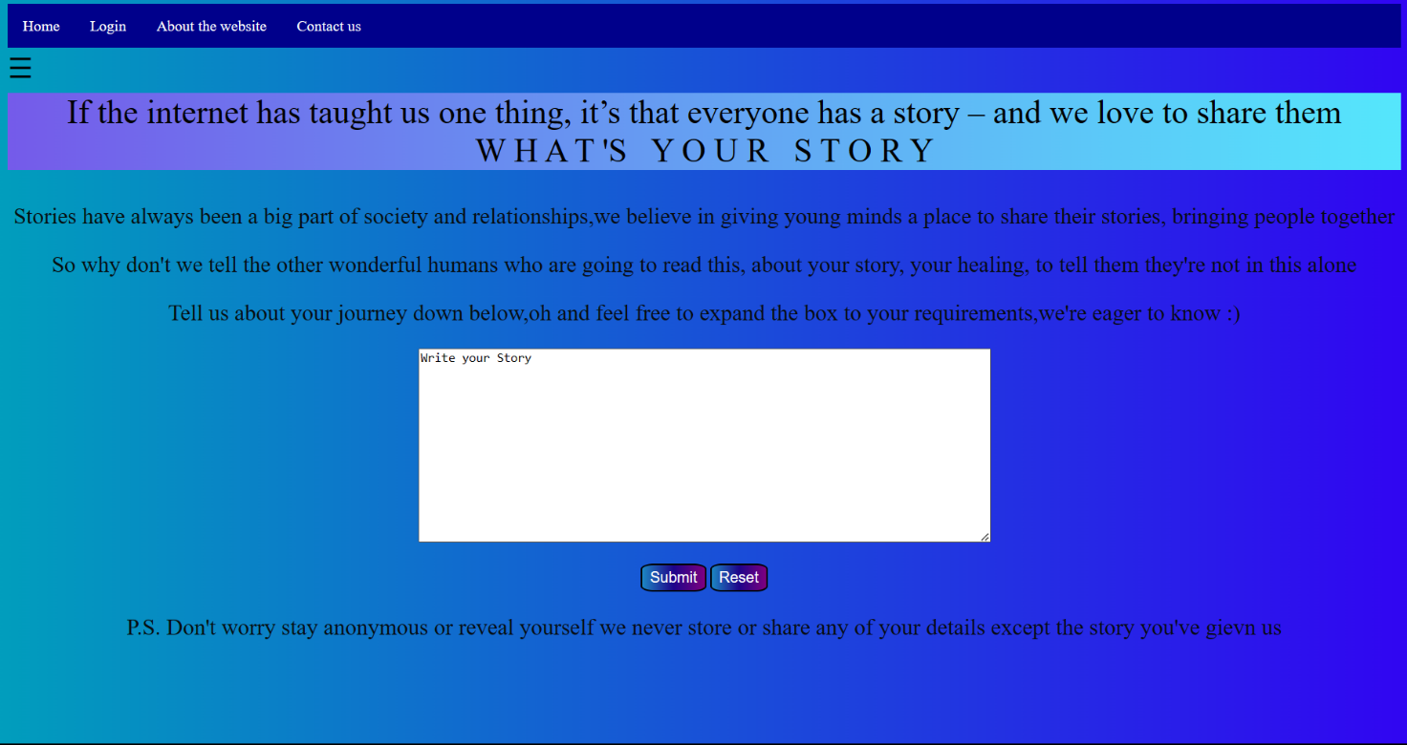

**Fig 6.6 Share your story page**

**Shareyourstory.html**

<!DOCTYPE html>

<html>

    <head>

        <title>

            What's your story

        </title>

        <link rel="stylesheet" href="sharestory.css"></link>

    </head>

    <body>

        <script>

          function openNav() {

              document.getElementById("mySidenav").style.width = "250px";

            }

            function closeNav() {

              document.getElementById("mySidenav").style.width = "0";

            }

                    </script>

                   <div id="mySidenav" class="sidenav">

        <a href="javascript:void(0)" class="closebtn" onclick="closeNav()">&times;</a>

        <a href="sharestory.html" target="blank_">Share your story</a>

        <a href="spotify.html" target="blank_">Curated playlists</a>

        <a href="feedback_form.html" target="blank_">Feedback</a>

      </div>

      <div class="container">

        <ul>

        <li><a href="main.html">Home</a></li>

          <li><a href="login.html">Login </a></li>

          <li><a href="#aboutus">About the website</a></li>

          <li><a href="#contact">Contact us</a></li>

         </ul>

      </div>

      <span style="font-size:30px;cursor:pointer" onclick="openNav()">&#9776; </span>

      <br>

      <br>

        <center>

        <p id="one">If the internet has

            taught us one thing, it’s that everyone has a story – and we love to share them<br/> W H A T 'S &nbsp; Y O U R &nbsp; S T O R Y

        <div id="two">

            <p>Stories have always been a big part of society and relationships,we believe in giving young minds a place to share their stories, bringing people together</p>

            <p>

                So why don't we tell the other wonderful humans who are going to read this, about your story, your healing, to tell them they're not in this alone

            </p>

            <p>

                Tell us about your journey down below,oh and feel free to expand the box to your requirements,we're eager to know :)

            </p>

            <form action="/sharestory" method="post">

            <textarea row=1000 column=1000 id="story" value="story" name="story" >Write your Story</textarea><br/>

            <br>

            <button id="reset" type="reset" onclick="window.location.href='main.html'" >Submit</button>

            <button id="reset" type="reset" onclick="window.location.href='sharestory.html'">Reset</button>

            </form>

            <p>

                P.S. Don't worry stay anonymous or reveal yourself we never store or share any of your details except the story you've gievn us

            </p>

                    </div>

            </body>

</html>

**Shareyourstory.css**

p{

    color: rgba(7, 10, 10, 0.973);

    font-size: 150%;

}

body{

    background: linear-gradient(90deg,#019ebd,#3105f2);

}

textarea{

    width:600px;

    height: 200px;

}

#one

{

    color:black;font-size:220%;

    text-align: center;

    background: linear-gradient(90deg,#755bea,#55e7fc);

    margin-top: -10px;

}

#two

{

    border-color: black;border-width: 30%;

}

#main{

    text-decoration: none;

    padding:10px;

    color:white;

    border:1px solid black;

    border-radius:20px;

    background:linear-gradient(90deg,rgb(28, 135, 197),rgb(30, 4, 138),purple);

}

#submit,#reset

{

    color:white;

    text-decoration: none;

    padding: 4px 8px;

    border-radius: 20%;

    font-size: 16px;

    background:linear-gradient(90deg,rgb(28, 135, 197),rgb(30, 4, 138),purple);

}

#h1{

background:linear-gradient(90deg,rgb(28, 135, 197),rgb(30, 4, 138),purple);

}

.sidenav {

    height: 100%;

    width: 0;

    position: fixed;

    z-index: 1;

    top: 0;

    left: 0;

    background-color: blue;

    overflow-x: hidden;

    transition: 1s;

    padding-top: 60px;

  }

  .sidenav a {

    float:left

    padding: 8px 8px 8px 32px;

    text-decoration: none;

    font-size: 25px;

    color: lightblue;

    display: block;

    transition:0.3s;

  }

  .sidenav a:hover {

    color: #f1f1f1;

  }

  .sidenav .closebtn {

    position: absolute;

    top: 0;

    right: 25px;

    font-size: 36px;

    margin-left: 50px;

  }

   /* The dots/bullets/indicators */

     .dot {

       cursor: pointer;

       height: 5px;

       width: 5px;

       margin: 0 2px;

       background-color: #bbb;

       border-radius:10%;

       display: inline-block;

       transition: background-color 0.6s ease;

     }

      .active,

     .dot:hover {

       background-color: #717171;

     }

      /* Fading animation */

     .fade {

       -webkit-animation-name: fade;

       -webkit-animation-duration: 1.5s;

       animation-name: fade;

       animation-duration: 1.5s;

     }

      ul {

        list-style-type: none;

        margin: 0;

        top: 10px;

        padding: 0;

        overflow: hidden;

        background-color: darkblue;

      }

      li {

        float: left;

      }

      li a {

        display: block;

        color: white;

        text-align: center;

        padding: 14px 16px;

        text-decoration: none;

      }

      a:hover {

        font-size: 30px;

        color: red;

      }

**6.5 CURATED SONGS PLAYLIST**

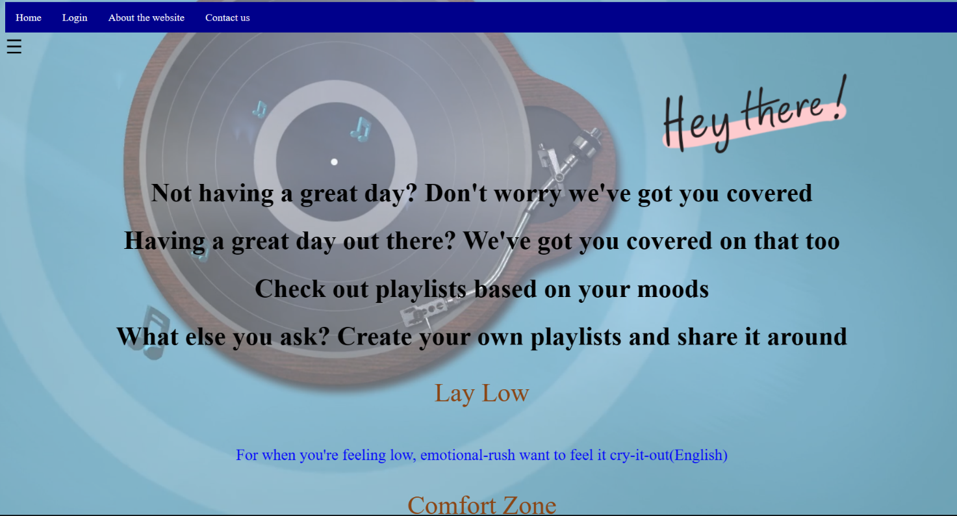

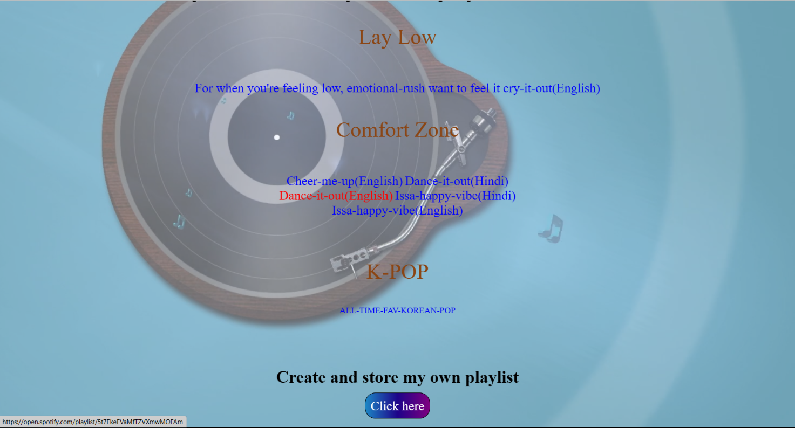

**Fig 6.7 Curated songs playlist page**

**Songs.html**

<!DOCTYPE html>

<html>

    <head>

        <title>Playlist your way through</title>

    <link rel="stylesheet" type="text/css" href="spotify.css">

      <video id="myVideo2" autoplay loop muted>

        <source src="dj.mp4" type="video/mp4" />

      </video>

    </head>

    <script>

        function openNav() {

          document.getElementById("mySidenav").style.width = "250px";

        }

        function closeNav() {

          document.getElementById("mySidenav").style.width = "0";

        }

        </script>

  <div id="mySidenav" class="sidenav">

    <a href="javascript:void(0)" class="closebtn" onclick="closeNav()">&times;</a>

    <a href="sharestory.html" target="blank_">Share your story</a>

    <a href="spotify.html" target="blank_">Curated playlists</a>

    <a href="feedback_form.html" target="blank_">Feedback</a>

  </div>

  <div class="container">

    <ul>

      <li><a href="main.html">Home</a></li>

      <li><a href="login.html">Login </a></li>

      <li><a href="#aboutus">About the website</a></li>

      <li><a href="#contact">Contact us</a></li>

     </ul>

  </div>

  <span style="font-size:30px;cursor:pointer" onclick="openNav()">&#9776; </span>

  <br>

  <br>

        <img class="heading1" src="heythere.png"></img>

        <center>

        <h1 id="heading" class="key1">Not having a great day? Don't worry we've got you covered</h1>

        <h1 id="heading" class="key1">Having a great day out there? We've got you covered on that too</h1>

        <h1>                                        </h1>

        <h1 id="heading" class="key1">Check out playlists based on your moods</h1>

        <h1 id="heading" class="key1">What else you ask? Create your own playlists and share it around</h1>

        <p style="font-size:250%;color:SaddleBrown"> Lay Low</p>

        <br/><a href="https://open.spotify.com/playlist/3fn599sglXTYLdsFqUQi0k" target="_blank" style="font-size: x-large;">For when you're feeling low, emotional-rush want to feel it cry-it-out(English)</a>

        <p style="font-size:250%;color:SaddleBrown">Comfort Zone</p>

         <br/><a href="https://open.spotify.com/playlist/0lag21D6boYMhfTaEVCcXG" target="_blank" style="font-size: x-large;">Cheer-me-up(English)</a>

        <a href="https://open.spotify.com/playlist/5tYKIVRoZgcgPy4dsexkvD" target="_blank" style="font-size: x-large;">Dance-it-out(Hindi)</a>

        <br/><a href="https://open.spotify.com/playlist/5t7EkeEVaMfTZVXmwMOFAm" target="_blank" style="font-size: x-large;">Dance-it-out(English)</a>

        <a href="https://open.spotify.com/playlist/5t7EkeEVaMfTZVXmwMOFAm" target="_blank" style="font-size: x-large;">Issa-happy-vibe(Hindi)</a>

        <br/><a href="https://open.spotify.com/playlist/5t7EkeEVaMfTZVXmwMOFAm" target="_blank" style="font-size: x-large;">Issa-happy-vibe(English)</a>

        <br/><br/><br/>

        <p style="font-size:250%;color:SaddleBrown">K-POP</p>

        <a href="https://open.spotify.com/playlist/5t7EkeEVaMfTZVXmwMOFAm" target="_blank" ">ALL-TIME-FAV-KOREAN-POP</a>

        <br/><br/><br/><br/><br/>

        <h1>Create and store my own playlist</h1><a id="clc" href="C:\Users\HP\Desktop\spotify2.htm" target="_blank" style="font-size: x-large;">Click here</a>

        <br/><br/>

       </center>

    </body>

    </html>

**Songs.css**

p{

    color: rgba(7, 10, 10, 0.973);

    font-size: 150%;

}

.sidenav {

    height: 100%;

    width: 0;

    position: fixed;

    z-index: 1;

    top: 0;

    left: 0;

    background-color: blue;

    overflow-x: hidden;

    transition: 1s;

    padding-top: 60px;

  }

  .sidenav a {

    float:left

    padding: 8px 8px 8px 32px;

    text-decoration: none;

    font-size: 25px;

    color: lightblue;

    display: block;

    transition:0.3s;

  }

  .sidenav a:hover {

    color: #f1f1f1;

  }

  .sidenav .closebtn {

    position: absolute;

    top: 0;

    right: 25px;

    font-size: 36px;

    margin-left: 50px;

  }

    ul {

        list-style-type: none;

        margin: 0;

        top: 10px;

        padding: 0;

        overflow: hidden;

        background-color: darkblue;

      }

          li {

        float: left;

      }

      li a {

        display: block;

        color: white;

        text-align: center;

        padding: 14px 16px;

        text-decoration: none;

      }

      a:hover {

        font-size: 30px;

        color: red;

      }

**6.6 FEEDBACK PAGE**

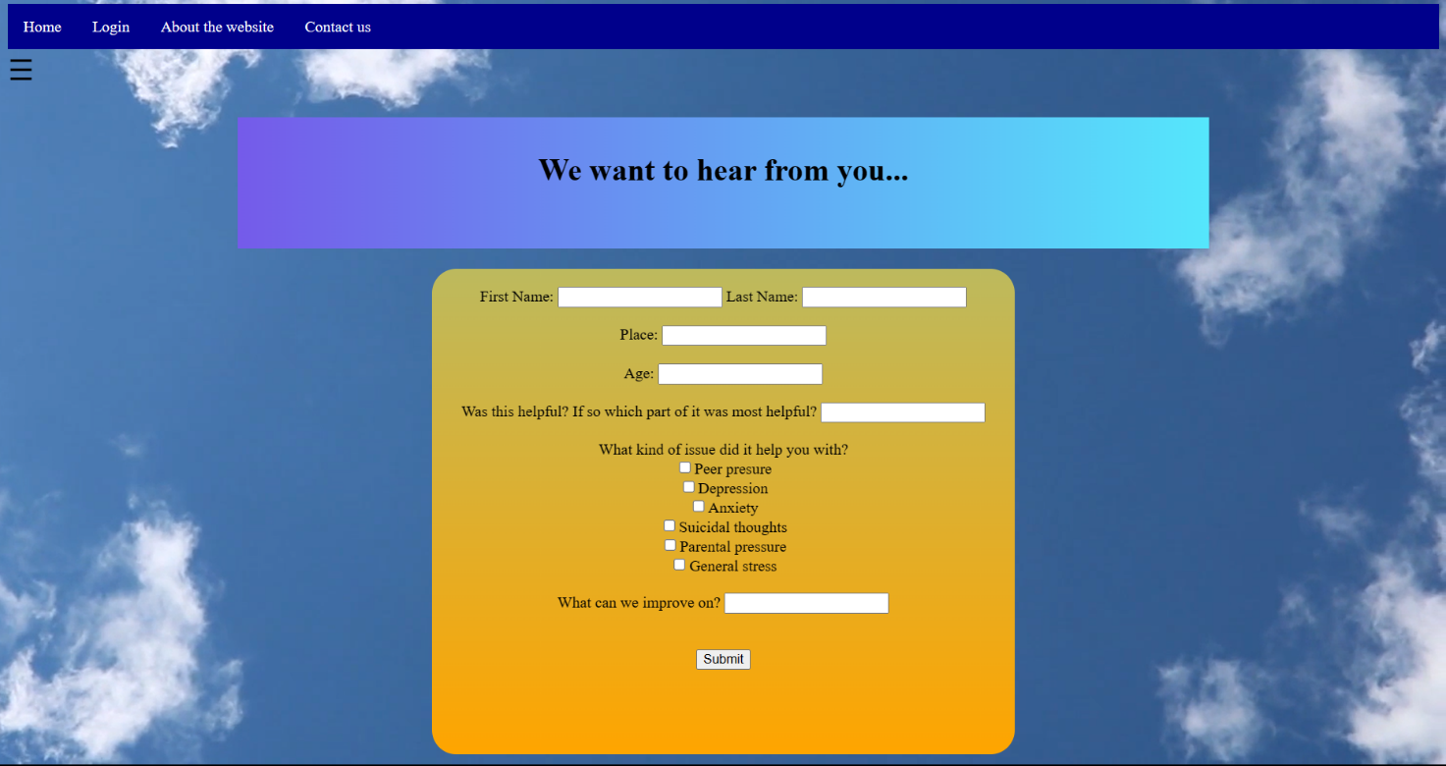

**Fig 6.8 Feedback page**

**Feedback.html**

<html>

  <head>

  <link rel="stylesheet" type="text/css" href="feedback.css">

    <script src="feedback.js"></script>

<title>Feedback</title>

  <video id="myVideo1" autoplay loop muted>

      <source src="vd.mp4" type="video/mp4" />

  </video>

  </head>

  <body>

    <script>

      function openNav() {

        document.getElementById("mySidenav").style.width = "250px";

      }

      function closeNav() {

        document.getElementById("mySidenav").style.width = "0";

      }

      </script>

  <div id="mySidenav" class="sidenav">

    <a href="javascript:void(0)" class="closebtn" onclick="closeNav()">&times;</a>

    <a href="sharestory.html" target="blank_">Share your story</a>

    <a href="spotify.html" target="blank_">Curated playlists</a>

    <a href="feedback_form.html" target="blank_">Feedback</a>

  </div>

  <div class="container">

    <ul>

      <li><a href="main.html">Home</a></li>

      <li><a href="login.html">Login </a></li>

      <li><a href="#aboutus">About the website</a></li>

      <li><a href="#contact">Contact us</a></li>

     </ul>

  </div>

  <span style="font-size:30px;cursor:pointer" onclick="openNav()">&#9776; </span>

    <div class="slideshow-container">

    <div class="mySlides fade">

      <h1 id="title">We want to hear from you...</h1>

    <div id="root"></div>

<center>

      <form  method="/formsubmit" action="post">

        <label><br/>

          First Name:

          <input type="text" name="fname"  />

        </label>

  <label>

          Last Name:

          <input type="text" name="lname" /><br/><br/>

        </label>

  <label>

          Place:

          <input type="text" name="place"  /><br/><br/>

  </label>

  <label>

          Age:

          <input type="text" name="age"  /><br/><br/>

        </label>

  <label>

          Was this helpful? If so which part of it was most helpful?

          <input type="textarea" name="help" /><br/><br/>

        </label>

  <label>

          What kind of issue did it help you with?

   <br>

  <input type="checkbox" name="issue2" />Peer presure <br/>

  <input type="checkbox" name="issue3" />Depression<br/>

  <input type="checkbox" name="issue4" />Anxiety<br/>

  <input type="checkbox" name="issue5" />Suicidal thoughts<br/>

  <input type="checkbox" name="issue6"  />Parental pressure<br/>

  <input type="checkbox" name="issue7"  />General stress<br/><br/>

  </label>

  <label>

          What can we improve on?

          <input type="textarea" name="improve"  /><br/>

        </label>

        <br>

        <br>

        <button type="reset" value="reset" onclick="window.location.href='main.html'" >Submit</button>

      </form>

    </center>

</body>

</html>

**Feedback.css**

body

{

        background-size: 100%;

}

#title{

    background: linear-gradient(90deg,#755bea,#55e7fc);

    height:100px;

    padding-top: 35px;

    margin-top: -20px;

}

form{

    background: linear-gradient(rgb(189, 186, 94),orange);

    width:600px;

    height:500px;

     border-radius: 25px;

    }

#myVideo1{

        position: fixed;

    right: 0;

    bottom: 0;

    min-width: 100%;

    min-height: 100%;

    z-index:-2;

}

.sidenav {

    height: 100%;

    width: 0;

    position: fixed;

    z-index: 1;

    top: 0;

    left: 0;

    background-color: blue;

    overflow-x: hidden;

    transition: 1s;

    padding-top: 60px;

  }

  .sidenav a {

    float:left

    padding: 8px 8px 8px 32px;

    text-decoration: none;

    font-size: 25px;

    color: lightblue;

    display: block;

    transition: 0.3s;

  }

  .sidenav a:hover {    color: #f1f1f1;  }

  .sidenav .closebtn {

    position: absolute;

    top: 0;

    right: 25px;

    font-size: 36px;

    margin-left: 50px;  }

       ul {

    list-style-type: none;

    margin: 0;

    top: 10px;

    padding: 0;

    overflow: hidden;

    background-color: darkblue;  }

  li {    float: left;  }

  li a {

    display: block;

    color: white;

    text-align: center;

    padding: 14px 16px;

    text-decoration: none;

  }

  a:hover {    font-size: 30px;

    color: red;  }

  /* Slideshow container */

  .slideshow-container {

    max-width: 1000px;

    position: relative;

    top: 51px;

    margin: auto;

    text-align: center;

  }

**CHAPTER-7**

**CONCLUSION AND FUTURE SCOPE**

**7.1 CONCLUSION**

In brief, ‘Mentality Plus’ is aimed towards developing a platform that enable people to improve their mental health online. It will be useful in reducing symptoms of mental health conditions, promoting stress management and overall wellness, and can be especially beneficial for individuals who may face barriers to accessing traditional mental health services.

**7.2 FUTURE SCOPE**

The actual result is still a prototype which can be improved if more time is given. Normally far more features should be implemented in order to obtain the product I envisioned. In order to make it completely functional and adapted to the actual market I’m planning to improve it on different levels.

* Dally check-ins and mood tracking: Include daily check-ins or mood tracking features, allowing users to track their emotions and mood over time. This can provide valuable insights into the user's mental health and help them identify patterns and triggers.
* Mindfulness and meditation exercises: Include mindfulness and meditation exercises, which can help users manage stress and anxiety and improve their overall mental well-being.
* Educational resources and information: Include educational resources and information on various mental health conditions, treatments, and coping strategies. This can help users better understand their mental health and make informed decisions about their care.
* Support communities: Include support communities, where users can connect with others who are facing similar challenges and offer support and encouragement.

**REFERENCES**

1. w3.org. [Online]. Available: https://www.w3.org/standards/webdesign/htmlcss.
2. JavaScriptTutorial[Online],Available: https://www.w3schools.com/js/default.asp
3. CSS Tutorial [Online], Available: <https://www.w3schools.com/css/default.asp>
4. “SDLC”[Online].Available:http://istqbexamcertification.com/whatarethesoftwaredevelopment-life-cycle-sdlc-phases/.
5. J. Duckeet, "Design and Build Websites," in Design and Build Websites (1'st Edition),2005